Name:__________________________ Date:____________________ Period:_______
What’s in a Character?
Directions: Look at the screenshots of each movie character below. List every detail that you notice in these scenes. What is the character wearing? What is he doing? What kind of environment is he in? What other objects are also in the shot? Based on your observations, choose three details that you find particularly interesting and write them in the third column next to “Observation.” What could these details say about the character’s personality? Remember, you are just making an educated guess – there is no one correct answer, since these details could have different interpretations.
Screenshot | What’s in the Shot? | What Does This Tell You?
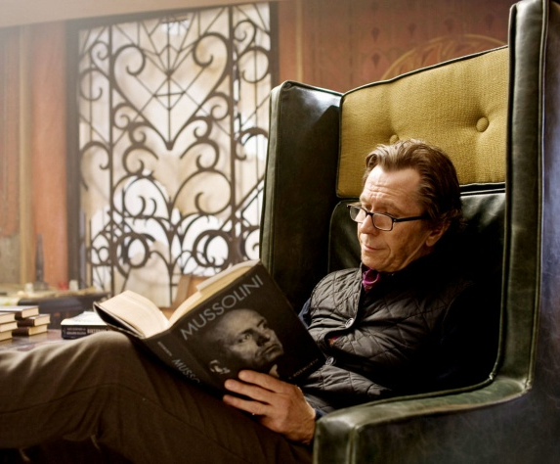  *Note: The title of his book is Mussolini. * | Clothing:___________________________  __________________________________  __________________________________  Body Language:_____________________  __________________________________  __________________________________  Location:__________________________  __________________________________  Surrounding Objects:________________  __________________________________  __________________________________ | Observation:___________________  ______________________________  Personality Trait:_______________  _____________________________  Observation:___________________  ______________________________  Personality Trait:________________  ______________________________  Observation:____________________  _______________________________  Personality Trait:________________  ______________________________
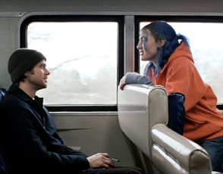  * Note: The girl is the character that I want you to look at here. | Clothing:___________________________  __________________________________  __________________________________  Body Language:_____________________  __________________________________  __________________________________  Location:__________________________  __________________________________  Surrounding Objects:________________  __________________________________  __________________________________ | Observation:___________________  ______________________________  Personality Trait:_______________  _____________________________  Observation:___________________  ______________________________  Personality Trait:________________  ______________________________  Observation:____________________  _______________________________  Personality Trait:________________  ______________________________
Name:____________________________ Date:____________________ Period:____________________
FILM TERM NOTES
I. Basic Film Terms
A. Shot: continuous footage between two _________; everything before a change in ______________ or _______________________ in a scene.
a. Close-up shot: the subject fills the ___________________. It may be the ________, another __________________, or an _____________________________.
b. Medium shot: shows the subject from the ______________ up.
c. Long shot: shows the entire subject from ____________ to _________.
d. Distance shot: shows the subject as extremely ____________ in relation to the ________________________________.
B. Scene: a series of _____________ (or one long one) that takes place in a single ___________________.
C. Framing: the way a _____________ is positioned in a ________________.
D. Editing: the way that ____________ are _________________________.
E. Mise-en-scène: a ______________ term meaning “___________________________,” or all the details that make up a shot (costumes, lighting, set design, etc).
II. Angles and Movement
A. High Angle Shot: the subject is shown from ____________, so that the viewers are looking _____________ on him/her.
B. Low Angle Shot: The subject is shown from ____________, so that the viewers are looking ___________ at him/her.
C. Pan: a camera movement from ___________ to ____________in a single shot.
D. Tilt: a camera movement ____________or _____________in a single shot.
E. Tracking Shot: a camera movement where the camera ______________ the subject on ______________, often riding on a track.
F. Zoom: going from a _____________________towards a __________________or vice versa. As the subject becomes closer, the background will become more ___________.

